COUNSELLING FAQs

- Where is the counselling venue?
Ans. The counselling of B.A.(Hons.) is held at Samta Bhawan(New PG Building), Faculty of Social Sciences, near Maitreyi Jalpan Grih in the BHU campus.
GOOGLE MAP LINK:

- How to reach the counselling venue?
Ans. Varanasi is well connected by air, road and rail. The nearest airport is the Lal Bahadur Shastri International Airport at Babatpur. The nearest railway stations are Varanasi Cantt., Manduadih ,Varanasi City stations. You can take a cab or an auto to reach Lanka. The BHU main gate is called Lanka gate. From there, you can comfortably reach the counselling venue by taking a rickshaw or an auto or even on foot.
Pic : LANKA GATE

- What is the process of counselling for admissions to undergraduate programs?
Ans. Out of the numerous candidates that apply for UET every year, about 550-600 get selected in the various programs of the Faculty of Social Sciences. A call letter is issued to all the candidates selected for counselling. Note that every year the number of call letters issued is almost double the number of seats available. Therefore, mere selection for counselling does not guarantee one an admission to the university. The allotment of seats is done solely on the basis of merit. The call letter can be downloaded by the candidate from the online portal where the result was declared(www.bhuonline.in). It contains the list of documents required for counselling and the slots of counselling in which the candidate is summoned on the basis of the rank secured in UET. The candidates must fill their choices of subjects in the preference entry form available on the counselling portal.

- How does one fill the online preference entry form?
Ans. The preference entry form shows the various combination of subjects available for the candidate to choose from. Each combination contains three core subjects, of which the first subject is the Honours; a language paper and an ancillary paper. The candidate is required to study all the five subjects for four semesters. In the final year, the candidate can decide his/her major(Hons.). It is important for the candidate to fill as many preferences as possible because the allotment of combination is subject to their rank.
During the allotment of subjects, the preference given by a candidate with higher marks is entertained first. If the number of seats for a given combination get exhausted and a candidate does not gets selected for that combination, he/she will then be competing for the subject combination entered next in preference to the previous one.
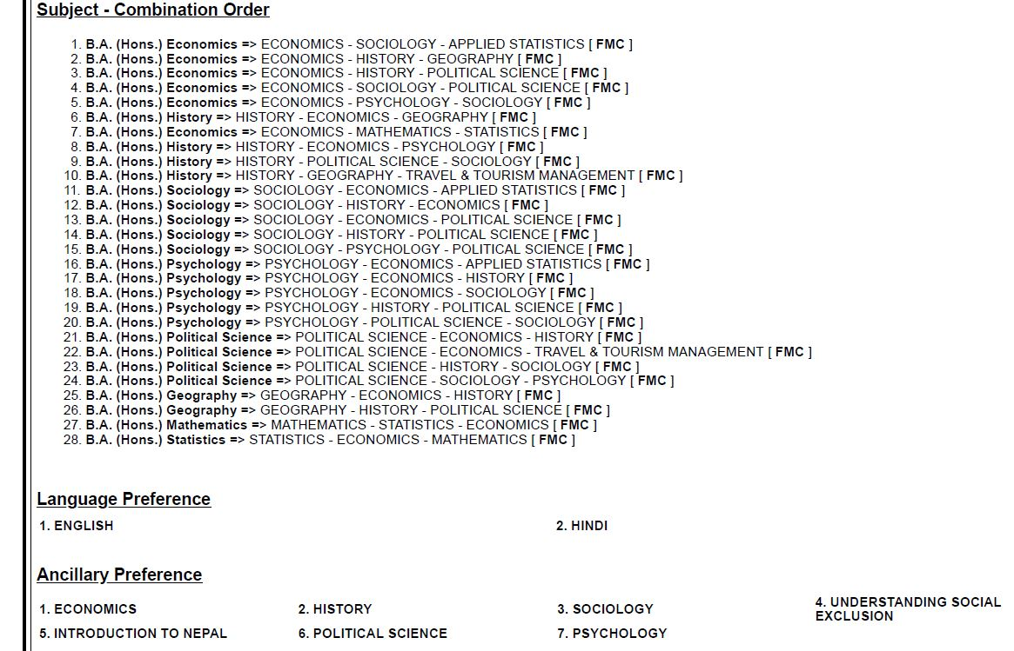

- What is core and ancillary?
Ans. Ancillary is a subject that is taught for the purpose of knowledge enhancement of the students. Pupils need to take up one course per semester of their chosen ancillary paper for the first two years. Your ancillary subject has to be different from the core subjects i.e. the three subjects in your combination.

- What language courses are offered in Social Sciences?
Ans. In spite of having a choice for languages in the preference entry form, the candidates compulsorily need to take up a course in Hindi or any Indian language for their freshman year and a course in English or any foreign language for their sophomore year.

- What documents are essential on the day of counselling?
Ans.

- What is regular seat and paid seat?
Ans. The faculty reserves a fixed number of seats in different subjects which are called paid seats. If a candidate does not get admission to the course of his/her choice but still wishes to pursue that course, he/she can do so by applying through the option of paid seat. However, paid seats are different from regular seats in terms of course fee. For availing the option of paid seat, a candidate has to pay ₹10,000 every year in addition to the regular amount of fee.

- What activities take place during the counselling?
Ans. The candidates themselves need to be physically present during the counselling. Any exceptions will not be entertained. On reaching the counselling spot, the candidate will be directed to a registration hall where their attendance will be marked and their documents will be scrutinised and put together in a file. After that, they will be called to a conference hall where their documents will again be scrutinised and their preference of subjects will be finalised. The candidates can discuss with the teachers on their choice of subjects and get any kind of academics doubts cleared. Note that this is the last stage where a candidate can edit his/her preference list. Once locked, no changes can be made in the preference form. The candidates can also take help from the student volunteers present at the venue.

10.When do the results of the counselling get declared?
Ans. The results get declared 6 PM in the evening of the same day as of counselling. The allotted course along with the fee gets displayed on the counselling portal.

11. How to pay the fee and lock the allotted combination?
Ans. The fee payment deadline is displayed next to the course allotted on the counselling portal. If the candidate is satisfied with the course allotted to him/her, an email saying, “Please lock my status.” needs to be sent to . If the candidate isn’t satisfied with the course allotted, he/she can choose the ‘Upgradation’ option.

12.What is course upgradation? How many times can the course be upgraded?
Ans. When a candidate is allotted a course which is lower in his/her preference, he/she has the option to let go of that course and wait until a course which was higher in the preference is allotted. This upgradation can take place a number of times depending on the seats available in the preferred courses.

13. What happens fee payment?
Ans. The candidate is considered admitted to the university once the fee is paid. A confirmation letter (called Admit Card) is generated, which contains the date of reporting in the Dean Office and the documents required on that day.

14. How is hostel allotted?
Ans. Hostels in FSS are scarce. So, the allotment of hostel rooms is done strictly on the basis of merit. Candidates need to specify whether they need hostel in the choice filling form itself.
The hostel allotted to the candidate gets displayed in the ‘Hostel Allotment’ section of the counselling portal a few days after the counselling gets over. Candidates need to pay the hostel fee for the first semester, as mentioned on the portal and report to the respective hostels on the date mentioned in the hostel admit card which gets generated once the hostel fees are paid.

15. What happens on the day of reporting?
Ans. On the day of reporting, the candidates need to submit the original copy of Transfer certificate, Migration certificate and Character certificate (from the Board last attended), an Anti-Ragging form and Dossier (Resident Agreement) form in the office of the Dean.
The Anti-Ragging form and the Dossier are available on the portal.

16. When are the rooms in the hostel allotted?
Ans. When the candidate reports to the allotted hostels on the date mentioned in the ‘Hostel Admit Card’, a room gets allotted to him/her prior to which he/she needs to submit the dossier form in the office of the Warden. Students can shift to their respective rooms from the day of allotment itself or as per their convenience.

17. What are the residential facilities for candidates who don’t get hostels?
Ans. There are various PGs, hostels and flats available in areas around the university for students who don’t get hostels. Students can find residences in areas like Lanka, Chittupur, Durgakund, Naria etc.

18. When do the classes get started?
Ans. Classes for the first year get started around the last week of July and the first week of August. The exact date is put up on the notice outside the Dean’s Office on the day of reporting. Furthermore, the candidates can check the notice-board of their respective departments for more details.

19. Where are lectures of first year held?
Ans. The departments of Political Science and Psychology are in the Old P.G. Building (Samanvay Bhawan). The departments of Geography, Mathematics, Statistics and Applied Statistics are in the Institute of Science, adjacent to Samanvay Bhawan. The departments of Sociology and History are in the New P.G. Building (Samta Bhawan) and the department of Economics has a separate building located beside the Department of Bhojpuri (behind Samta Bhawan).
However, most of the first year lectures are held in the Old P.G. Building and in the lecture theatre in the Faculty of Arts, except that of Geography and Statistics, which are held in their respective departments.

20. Which documents are needed by a student to avail various facilities in the university?
Ans. A student of B.H.U. must have an identity card (called Passbook), a health card, library cards and a Proxy id of B.H.U Wi-Fi. These documents are made available to the students from the second week of August.

